Conflict Management in Medical Education
Conflict, discord, struggle – by whatever name we call it we can all be certain it exists within the realm of medical education. As educational leaders within the organization, faculty are tasked with navigating challenging conflicts with students, residents, staff, and/or patients. Conflict within medical education and healthcare is a growing concern that is being addressed within many programs (Cochran, 2018). However, despite the development of learner programs focused on conflict management many conflicts remain unresolved or unsatisfactorily resolved (Saltman, 2006). The value of conflict management training within medical education has been captured in the literature, but we continue to identify effective ways to teach these skills in medical school, residency, and to our educational leaders (Cochran, 2018).
Disagreement and conflict are an inevitability among clinical teams given the fast paced and high-stakes environment. When conflict persists, effective communication and workplace productivity are negatively impacted (Kaufman, 2011). It is critical for healthcare team members, especially leaders, to develop skills for negotiating and resolving inevitable conflicts. For faculty, it is important to identify effective conflict resolution models, strategies for dealing with conflict as it arises, and tips to effectively managing conflict to a satisfactory resolution for all parties involved (Saltman, 2006). Medical education and healthcare are hierarchical environments and conflicts often span different levels of the educational hierarchy; it is critical that approaches taken to conflict management in these arenas should ensure the preservation of the critical interpersonal relationships that exist (Saltman, 2006). While best practices for teaching conflict management skills in the clinical setting may not be standardized, there are several steps that can be taken in preparation for navigating (and guiding learners to navigate) conflicts:
- Become aware of the different conflict management styles overall styles and recognize the value in each. Conflict resolution style and approach may vary among situations and relationships.
- Recognize the importance of both verbal and nonverbal communication as essential elements in conflict resolution.
- Identify sources of potential/real conflict and dynamics that can lead to conflict.
- Identify a structured approach to conflict resolution that emphasizes professionalism and preservation of relationships among the team.
- To be effective educational leaders during conflict resolution, separate interests (underlying goal or concern) from positions (statement or action).
- Recognize differences among the views of individuals embroiled in the conflict to help establish common goals, identify unmet needs, and identify creative solutions.
- Work to differentiate between intention and impact to help identify unanticipated negative impact of actions and reframe interactions.
- Encourage self-reflection to recognize internal biases, understand contributions to the conflict, and identify potentially incorrect assumptions about the situation.
Conflicts in the realm of medical education will take on many forms: interdisciplinary conflicts, ethical conflicts, and/or conflicts among members of the educational hierarchy. As educational leaders, faculty need to ensure familiarity with conflict management styles and techniques. Conflict management is foundational to handling all disagreements and requires a familiarity with interpersonal skills such as active listening, addressing emotional aspects of a situation, building trust and empathy, discussing options, and establishing limits (Rosenman, 2017). Conflict must be addressed in order to ensure quality care among healthcare teams, and with many sources of conflict there is a variety of appropriate conflict resolution toolkits and models that can be utilized for each unique approach (Kaufman).
This month, Dean Learman led a Current Topics presentation on “Understanding and Managing Conflict in Medical Education.” During the interactive session, Dean Learman reviewed cause of conflict and countermeasures, described individual styles for managing conflict, and shared insights into addressing real-world conflicts in medical education. Please head over to the OCPD website to view this informative presentation and to learn more about conflict management in medical education!

Conflict resolution styles and key features of styles defined by Thomas and Kilmann

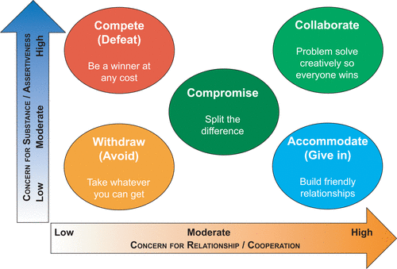

References:

Cochran, N., Charlton, P., Reed, V., Thurber, P., & Fisher, E. (2018). Beyond fight or flight: the need for conflict management training in medical education. Conflict Resolution Quarterly, 35(4), 393-402.

Kaufman, J. (2011). Conflict management education in medicine: considerations for curriculum designers. Online Journal for Workforce Education and Development, 5(1), 6.

Rosenman, E. D., Vrablik, M. C., Charlton, P. W., Chipman, A. K., & Fernandez, R. (2017). Promoting workplace safety: teaching conflict management and de-escalation skills in graduate medical education. Journal of graduate medical education, 9(5), 562.

Saltman, D. C., O’dea, N. A., & Kidd, M. R. (2006). Conflict management: a primer for doctors in training. Postgraduate medical journal, 82(963), 9-12.

Wolfe, A. D., Hoang, K. B., & Denniston, S. F. (2018). Teaching conflict resolution in medicine: lessons from business, diplomacy, and theatre. MedEdPORTAL, 14.

